 | 5.1.1 Topbar and Statusbar - File menu

Table of content
Detailed table of content 1
File Menu 11
New 11
New from Template 11
Open 12
Open Recent 12
Revert 12
Recover last Session 12
Recover Autosave 12
Save 12
Incremental Save 12
Save As 12
Save Copy 12
Link 12
Append 14
Data Previews 15
Import 16
Export 30
External Data 51
Clean Up 53
Quit 53

Detailed table of content
Detailed table of content
Detailed table of content 1
File Menu 11
New 11
New from Template 11
Standard Application Templates 11
General 11
2D Animation 11
All 11
Sculpting 11
VFX 11
Video Editing 12
Open 12
Open Recent 12
Revert 12
Recover last Session 12
Recover Autosave 12
Save 12
Incremental Save 12
Save As 12
Save Copy 12
Link 12
Advanced Filter 13
Import Settings 13
Relative Path 13
Select 13
Active Layer 13
Instance Collections 13
Please Note: 13
Known Limitations 13
Append 14
Advanced Filter 14
Import Settings 14
Select 14
Active Collection 14
Instance Collection 14
Fake User 14
Localize All 14
Data Previews 15
Refresh Data Set Previews 16
Batch Generate Previews 16
Clear Data Set Previews 16
Batch Clear Previews 16
Import 16
Operator Presets 16
Operator Presets dropdown 17
Restore Operator Defaults 17
List of available presets 17
Add Operator Preset 17
Remove Operator Preset 17
Collada 17
Import Data Options 17
Import Units 17
Custom Normals 17
Armature Options 17
Fix Leaf Bones 17
Find Bone Chains 17
Auto Connect 17
Minimum Chain Length 18
Keep Bind Info 18
Alembic 18
Manual Transform 18
Scale 18
Options 18
Relative Path 18
Set Frame Range 18
Is Sequence 18
Validate Meshes 18
Always add Cache Reader 18
USD 19
Data Types 19
Cameras 19
Curves 19
Lights 19
Materials 19
Meshes 19
Volumes 19
Shapes 19
Skeletons 19
Blend Shapes 19
Path Mask 19
Scale 19
Mesh Data 19
UV Coordinates 19
Vertex Colors 20
Mesh Attributes 20
Include 20
Subdivision 20
Import Instance Proxies 20
Visible Primitives Only 20
Guide 20
Proxy 20
Render 20
Options 20
Set Frame Range 20
Relative Path 20
Create Collection 20
Light Intensity Scale 20
Materials 20
Import all Materials 20
Import USD Preview 21
Set Material Blend 21
Material Name 21
Import Textures 21
None 21
Packed 21
Copy 21
Textures Directory 21
File name collision 21
SVG as Grease Pencil 21
Resolution 21
Scale 21
Wavefront(OBJ) 22
Transform Panel 22
Scale 22
Clamp Bounding Box 22
Forward Axis 22
Up 22
Options 22
Split by Object 22
Split by Group 22
Vertex Groups 22
Validate Meshes 22
Motion Capture (BVH) 23
Target 23
Transform panel 23
Scale 23
Rotation 23
Forward 23
Up 23
Animation Panel 23
Start Frame 23
Scale FPS 23
Loop 23
Update Scene FPS 23
Update Scene Duration 24
Scalable Vector Graphics (SVG) 24
Stanford (PLY) 24
Scale 24
Scene Unit 24
Forward Axis 24
Up Axis 24
Merge Vertices 24
Vertex Colors 24
Vertex Attributes 24
STL 25
Transform Panel 25
Scale 25
Scene Unit 25
Forward 25
Up 25
Facet Normals 25
FBX 25
Include Panel 26
Custom Normals 26
Subdivision Data 26
Custom Properties 26
Import Enums as Strings 26
Image Search 26
Transform Panel 26
Scale 26
Decal Offset 26
!Experimental! Apply Transform 26
Use Pre/ Post Rotation 26
Manual Orientation panel 27
Forward 27
Up 27
Animation Panel 27
Animation Offset 27
Armature Panel 27
Ignore Leaf Bones 27
Force Connect Children 27
Automatic Bone Orientation 27
Primary and secondary Bone Axis 27
glTF 2.0 (glb, gltf ) 27
Pack Images 28
Merge Vertices 28
Shading 28
Guess original bind pose 28
Bone Direction 28
Wavefront(OBJ) (legacy) 28
Include panel 28
Image Search 28
Smooth Groups 28
Lines 29
Transform Panel 29
Clamp Size 29
Up 29
Geometry Panel 29
Split / Keep Vert Order 29
Split by Object 29
Split by Group 29
Keep Vert Order Poly Groups 29
X3D Extensible 3D 29
Transform Panel 30
Forward 30
Up 30
Export 30
Operator Presets 30
Operator Presets dropdown 30
Restore Operator Defaults 30
List of available presets 30
Add Operator Preset 30
Remove Operator Preset 30
Collada 31
Main 31
Selection Only 31
Include Children 31
Include Armatures 31
Include Shape Keys 31
Global Orientation 31
Apply 31
Forward Axis 31
Up Axis 31
Texture Options 31
Copy 31
UV 31
Only Selected Map 31
Geom 31
Export Data Options 32
Triangulate 32
Apply Modifiers 32
Transform 32
Arm 32
Armature Options 32
Deform Bones only 32
Export to SL/OpenSim 32
Anim 32
Include Animations 32
Key Type 32
Samples/Curves 32
Keep Smooth Curve 32
Sampling Rate 32
Keep Key frames 32
All Keyed Curves 33
Include all Actions 33
Transform Type 33
Extra 33
Collada Options 33
Use Object Instances 33
Use Blender Profile 33
Sort by Object Name 33
Keep Bind Info 33
Limit Precision 33
Alembic 33
Manual Transform 33
Scale 33
Scene Options 34
Frame Start 34
End 34
Samples Transform 34
Geometry Samples 34
Shutter Open 34
Shutter Closed 34
Use Instancing 34
Custom Properties 34
Flatten Hierarchy 34
Only 34
Selected Objects 34
Visible Objects 34
Object Options 35
UV's 35
Pack UV Islands 35
Normals 35
Vertex Colors 35
Generate Coordinates 35
Face Sets 35
Curves as Mesh 35
Subdivisions 35
Apply 35
Use Schema 35
Triangulate 35
Quad Method 35
Polygon Method 35
Particle Systems 36
Export Hair 36
Export Particles 36
Universal Scene Description ( USD ) 36
Export settings 36
Selection Only 36
Visible Only 36
Animation 36
Hair 36
UV Maps 36
Normals 36
Materials 36
Use Settings for 36
Materials 37
To USD Preview Surface 37
Export Textures 37
Overwrite Textures 37
File References 37
Relative Texture Paths 37
Experimental 37
Instancing 37
Grease Pencil as SVG 37
Scene Options 37
Object 37
Export Options 37
Sampling 37
Fill 37
Normalize 37
Clip Camera 37
Grease Pencil as PDF 38
Scene Options 38
Object 38
Export Options 38
Frame 38
Sampling 38
Fill 38
Normalize 38
Wavefront(OBJ) 39
Limit to 39
Selected Only 39
Scale 39
Forward Axis 39
Up Axis 39
Object 39
Apply Modifiers 39
Properties 39
Geometry 40
Materials 40
Export 40
PBR Extensions 40
Path Mode 40
Grouping export 40
Animation 40
Export Animation 40
Frame Start / End 40
Motion Capture BVH 41
Transform Panel 41
Scale 41
Rotation 41
Root Translation Only 41
Animation Panel 41
Start Frame 41
End Frame 41
Stanford (PLY) 41
Format 41
Ascii 41
Limit to 41
Selected only 41
Scale 41
Forward Axis 41
Up Axis 42
Objects 42
Apply Modifiers 42
Geometry 42
UV Coordinates 42
Vertex Normals 42
UV's 42
Vertex Colors 42
Vertex Attributes 42
Triangulated Mesh 42
STL 42
ASCII 42
Batch Mode 43
Include Panel 43
Selected Only 43
Transform Panel 43
Scale 43
Scene Unit 43
Forward 43
Up 43
Geometry panel 43
Apply Modifiers 43
FBX 43
Path Mode 44
Embed Textures 44
Batch Mode 44
Batch Own Dir 44
Include Panel 44
Limit to 44
Selected Objects 44
Active Collection 44
Object Types 44
Custom Properties 44
Transform Panel 44
Scale 44
Apply Scaling 44
Forward 44
Up 45
Apply Unit 45
Use Space Transform 45
!Experimental! Apply Transform 45
Geometry Panel 45
Smoothing 45
Export Subdivision Surface 45
Apply Modifiers 45
Loose Edges 45
Tangent Space 45
Armatures 45
Primary Bone Axis 45
Secondary Bone Axis 45
Armature FBX Node Type 46
Only Deform Bones 46
Add Leaf Bones 46
Bake Animation 46
Key all Bones 46
NLA Strips 46
All Actions 46
Force Start/ End Keying 46
Sampling Rate 46
Simplify 46
glTF 2.0 (glb, gltf ) 46
Format 47
Copyright 47
Remember Export Settings 47
Include panel 47
Limit to 47
Selected Objects 47
Visible Objects 47
Renderable Objects 47
Active Collection 47
Active Scene 47
Data 47
Custom Properties 47
Cameras 47
Punctual Lights 47
Transform Panel 47
Y Up 47
Geometry Panel 48
Apply Modifiers 48
UV's 48
Normals 48
Tangents 48
Vertex Colors 48
Loose Edges 48
Loose Points 48
Materials 48
Images 48
Automatic 48
Jpeg Format (jpg) 48
None 48
Compression sub subpanel 48
Animation 49
Use Current Frame 49
Animation sub subpanel 49
Limit to Playback Range 49
Sampling Rate 49
Always Sample Animations 49
Group by NLA Tracks 49
Export Deformation Bones only 49
Shape Keys sub subpanel 49
Shape Key Normals 49
Shape Key Tangents 49
Skinning 49
Include all Bone Influences 49
X3D Extensible 3D 49
Include Panel 50
Selection Only 50
Hierarchy 50
Name Decorations 50
H3D Extensions 50
Transform Panel 50
Scale 50
Forward 50
Up 50
Geometry Panel 50
Apply Modifiers 50
Triangulate 50
Normals 50
Compress 50
External Data 51
Automatically Pack into .blend 51
Pack Resources 51
Pack linked libraries 51
Unpack linked libraries 51
Unpack Resources 51
Use Files in current Directory (create when necessary) 52
Write files to current directory (overwrite existing files) 52
Use files in original location (create when necessary) 52
Write files to original location(overwrite existing files) 52
Make Paths Relative 52
Make Paths Absolute 52
Report Missing Files 52
Find Missing Files 52
Clean Up 53
Unused Data 53
Recursive Unused Data 53
Unused Linked Data 53
Recursive Unused Linked Data 53
Unused Local Data 53
Recursive Unused Local Data 53
Quit 53

File Menu
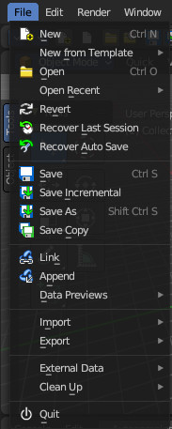
The File menu contains file related functionality.

New
Creates a new scene, using the current active template.

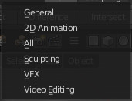
New from Template
Choose to create a new file with predefined Application Templates.
Application templates is a collection of workspaces for a predefined purpose.

Standard Application Templates

General
The general application template comes with the workspaces to create 3D content.

2D Animation
The 2D Animation application template comes with the workspaces to create 2D animation.

All
The All application template contains all default workspaces.

Sculpting
The Sculpting application template comes with the workspaces for sculpting needs.

VFX
The VFX application template comes with the workspaces for motion tracking.

Video Editing
The Video Editing application template comes with the workspaces for video editing.

Open
Open a blend file.

Open Recent
Open last recent blend files.

Revert
Reload the last saved file.

Recover last Session
Open the last closed blend file. (quit.blend)

Recover Autosave
Open the last autosaved blend file.

Save
Save blend file.

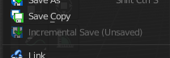
Incremental Save
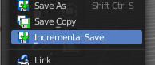
Saves an already saved blend file with incremental file name. myfile.blend gets saved as myfile1.blend, myfile2.blend, myfile3.blend, and so on.
You need to have the blend file saved once to set this save method active.

Save As
Save blend file as.

Save Copy
Saves a copy of the current file.

Link
Link allows you to link content from another blend file. The content remains in the other blend file. The linked blend file will be required to work with the linked content.
When you click at Link then a file browser will open. Down left you will see some further options.

Advanced Filter
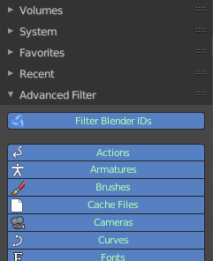
This filter allows you to filter the content of the blend file for specific object types.

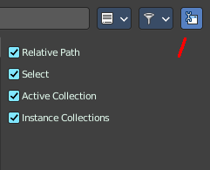
Import Settings
At the right you can reveal the import settings.

Relative Path
Available only when linking, see relative paths.

Select
Makes the object Active after it is loaded.

Active Layer
Enabled by default, the object is assigned to the visible layers in your scene. Otherwise, it is assigned to the same layers it resides on in the source file.

Instance Collections
This option links the collection to an object, adding it to the active scene.

Please Note:
When you select an Object type, it will be placed in your scene at the cursor. Many other data types - cameras, curves, and materials for example - must be linked to an object before they become visible.
You cannot move a linked object. Its position is defined in its source file. If you want to modify the object locally you can either use Dupli Groups or make the object local, in the 3D View, Object / Relations menu.
Appending data you already have linked, will add objects / groups to the scene, but will keep them linked (and un-editable).

Known Limitations
In general dependencies shouldn’t go in both directions. Attempting to link or append data which links back to the current file will likely result in missing links.
When linking objects directly into a .blend file, the Rigid Body settings won’t be linked in since they’re associated with their scenes world. As an alternative you could link in the entire scene and set it as a Background Set Scene.

Append
Append allows you to append content from another blend file. The content will be copied over, and become part of the current blend file.
When you click at Link then a file browser will open. Down left you will see some further options.
The difference to Link is that with Append the object becomes part of the current blend file. And it is editable.

Advanced Filter
This filter allows you to filter the content of the blend file for specific object types.

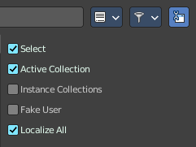
Import Settings
At the right you can reveal the import settings.

Select
Makes the object Active after it is loaded.

Active Collection
Put the new objects into the active collection.

Instance Collection
Create instances for collections rather than adding them directly to the scene.

Fake User
Set Fake User for appended objects, except Objects and Groups

Localize All
Localize all appended data, including indirectly linked from other libraries.

Data Previews
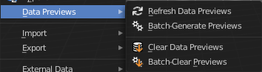
Data Previews is a sub menu with functionality around the Data Preview in the Bforartists file browser. The functionality in this menu creates and handles previews of the objects in a blend file.
Data Previews are displayed in the file browser when you link or append something from this file and when you use thumbnails as display method. It is meant for the case when you want to turn a blend file into an asset library. Materials, ready textured objects, etc. .
This feature is currently broken. You can't create data previews yet in Bforartists 2. Example images taken from Bforartists 1.
Workflow:
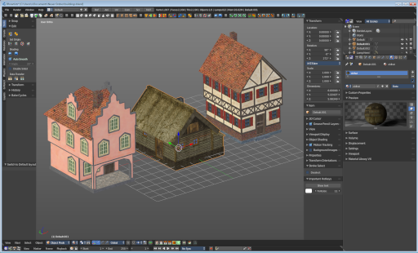
First create a scene with your assets. Make sure to remove the camera from the scene. It can work, but it can also make trouble, and prevent the batch generation to work at the blend file. And an asset library doesn't need a camera anyways. Not so important is lights, it does not make trouble like the camera. But you won't get a data preview icon for lights.
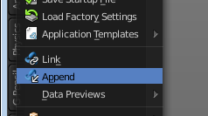
Save the scene. Restart Bforartists or create at least a new scene. We want to have a look what we currently get as preview when we want to link or append from this blend file. Make sure to turn the view in the file browser to thumbnails. It's always just the default icon for the assets. Left Materials, right the Objects.

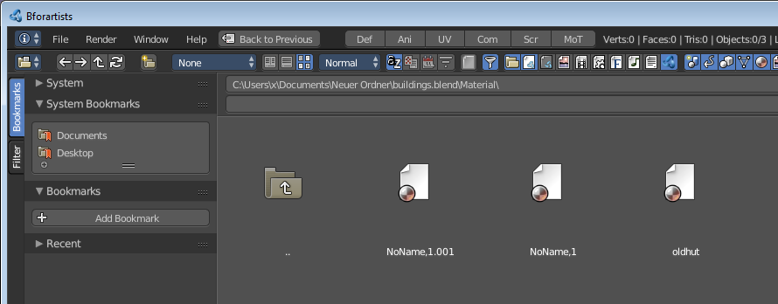
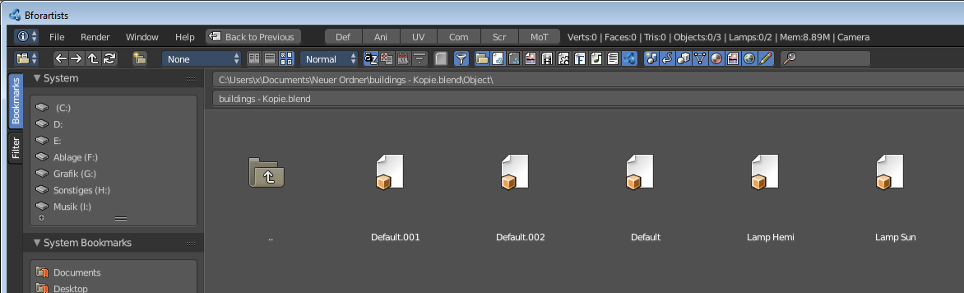

Now let's run Batch Generate Previews at this blend file.
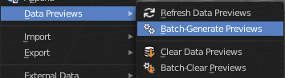
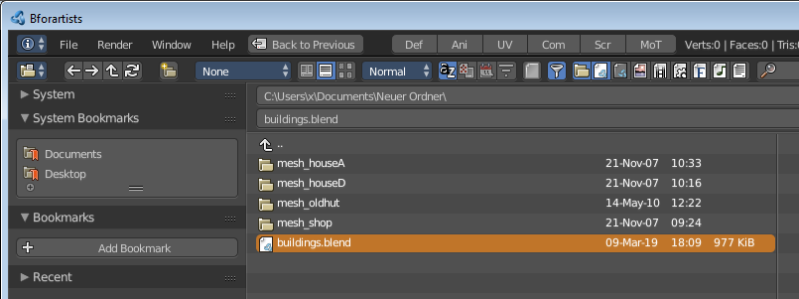

This process takes a while. Now let's try to append from the same file again. You will get proper preview thumbnails now. Left Materials, right the objects. Here you will see again that lamps have no preview icon.
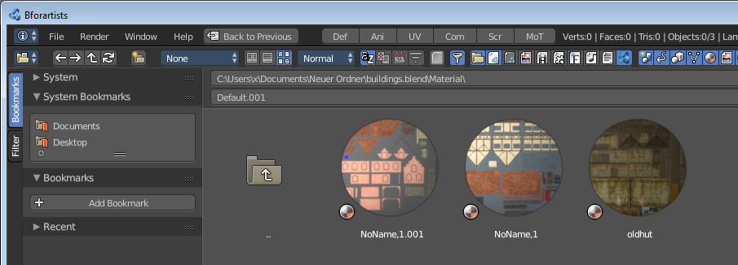
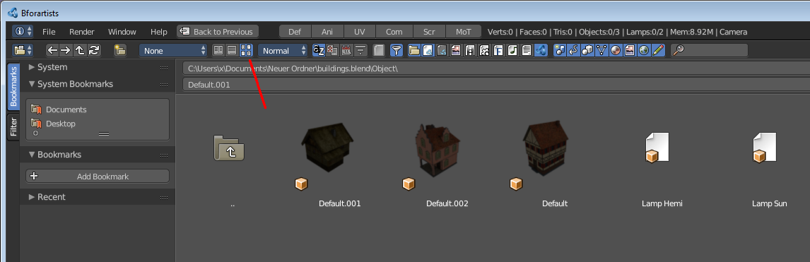

Refresh Data Set Previews
Refreshes the existing data set previews.

Batch Generate Previews
Generates the previews for the data objects in the selected blend file(s). The scene that you want to work at should not be loaded.

Clear Data Set Previews
Removes existing previews for some types in the target blend file.

Batch Clear Previews
Removes all existing previews in the target blend file.

Import
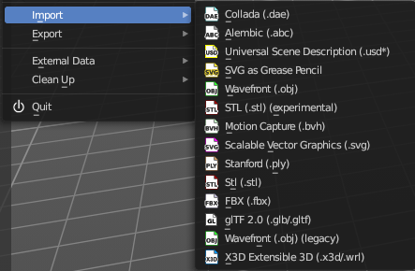
Import is a sub menu with the available 3D import file formats. You will be prompted to the load dialog which provides some further import options down left in the file browser tool shelf.

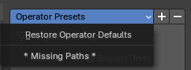
Operator Presets
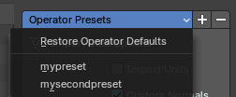
The operator presets exists on nearly all im- and exporters. Exceptions are for example the stl importer. They allow you to reset the importer settings to the defaults. And allow you to store your own presets. The presets are just valid for the im- or exporter with which you have saved the presets.

Operator Presets dropdown

Restore Operator Defaults
Restores the im or exporter settings to their default values

List of available presets
The list of available presets. The string *Missing Paths* indicates that no custom preset exists yet.

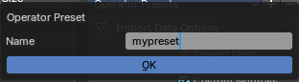
Add Operator Preset
Adds a new operator preset. A popup dialog will appear where you can give the new preset a name.

Remove Operator Preset
Removes the active preset. Note that you cannot display the current active preset. So choose it from the list, and then click at the remove operator.

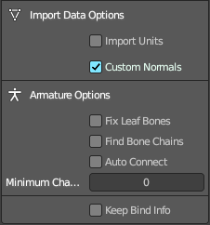
Collada
Imports a file in collada file format. Collada is a general file format that is able to store and load animation.

Import Data Options

Import Units
Imports the units that is used to save the collada file . If unticked Blender Units will be used.

Custom Normals
Import custom normals if available.

Armature Options

Fix Leaf Bones
Fix orientation of Leaf bones. Collada file formats only supports joints, not bones.

Find Bone Chains
Find best matching bone chains and ensure that the bones in the chain are connected.

Auto Connect
Auto connect parent bones that have exactly one child bone.

Minimum Chain Length
When searching bone chains disregard chains of length below this value.

Keep Bind Info
Store Bindpose Information in custom bone properties for later use in later collada export.

Alembic
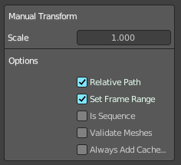
The alembic file format is for static geometry. It does not support armatures, hair or particles.

Manual Transform

Scale
Set the import scale factor.

Options

Relative Path
Select the file relative to the blend file.

Set Frame Range
Sets the Frame range start and end point in Bforartists to match the one in the alembic file.

Is Sequence
Import sequenced files that are split in cache parts.

Validate Meshes
Check for invalid mesh data in the file. Note that this operation may take some time.

Always add Cache Reader
Add cache modifiers and constraints to imported objects even when they are not animated. This allows updating the alembic archive when reloading.
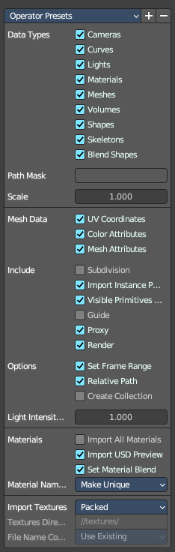

USD
Imports a Universal Scene Description (USD) file. It reads *.usd, *.usdc and *.usda files.

Data Types

Cameras
Import cameras (perspective and orthographic).

Curves
Import curve primitives, including USD basis and NURBS curves. (Note that support for Bézier basis is not yet fully implemented.)

Lights
Import lights. Does not currently include USD dome, cylinder or geometry lights.

Materials
Import materials. See also the experimental Import USD Preview option.

Meshes
Import meshes.

Volumes
Import USD OpenVDB field assets.

Shapes
Import USD Shapes.

Skeletons
Import USD Skeletons.

Blend Shapes
Import USD Blend Shapes.

Path Mask
Import only the subset of the USD scene rooted at the given primitive.

Scale
The scale size at import.

Mesh Data

UV Coordinates
Load mesh UV coordinates.

Vertex Colors
Import the USD mesh display Color values as Blender mesh vertex colors.

Mesh Attributes
Read USD PrimVars as mesh attributes.

Include

Subdivision
Create subdivision surface modifiers from the subdivision in the file.

Import Instance Proxies
Create unique Blender objects for USD instances.

Visible Primitives Only
Do not import invisible USD primitives. Only applies to primitives with a non-animated visibility attribute. Primitives with animated visibility will always be imported.

Guide
Include primitives with purpose guide.

Proxy
Include primitives with purpose proxy.

Render
Include primitives with purpose render.

Options

Set Frame Range
Update the scene’s start and end frame to match those of the USD stage.

Relative Path
Select the file relative to the blend file.

Create Collection
Add all imported objects to a new collection.

Light Intensity Scale
Scale for the intensity of imported lights.

Materials

Import all Materials
Import all materials. Also materials that are not used by the geometry.

Import USD Preview
Convert USD Preview Surface shaders to Principled BSDF shader networks.

Set Material Blend
If the Import USD Preview option is enabled, the material blend method will automatically be set based on the opacity and opacityThreshold shader inputs, allowing for visualization of transparent objects.

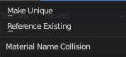
Material Name
How to import the material name when it conflicts with an existing material in the scene.

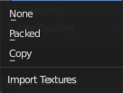
Import Textures
How to import textures.

None
Don't import textures.

Packed
Import Texture as packed data.

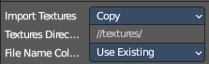
Copy
Copy files to texture directory.

Textures Directory
The textures directory.

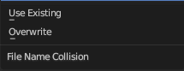
File name collision
What to do if a texture name already exists.

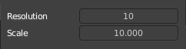
SVG as Grease Pencil
Imports a svg file as a grease pencil object.

Resolution
The resolution of the svg import.

Scale
The scale of the svg import.

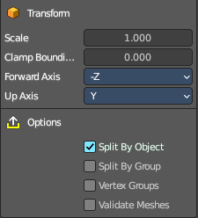
Wavefront(OBJ)

Transform Panel

Scale
Scale factor for the obj import.

Clamp Bounding Box
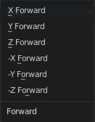
Clamp bounds under this value. A value of zero disables this feature.

Forward Axis
The Forward orientation at import.

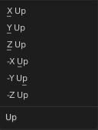
Up
The Up orientation at import.

Options

Split by Object
Import loose mesh parts as single objects.

Split by Group
Import Obj Groups as meshes.

Vertex Groups
Import Obj groups as vertex groups.

Validate Meshes
Check at import for invalid data.

Motion Capture (BVH)
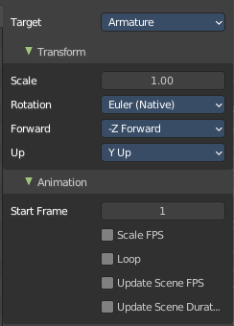
The Biovision Hierarchy (BVH) character animation file format is a file format to carry motion capture data.

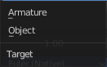
Target
You can either target an armature or an object.

Transform panel

Scale
The import scale.

Rotation
The rotation type.

Forward
The forward orientation.

Up
The Up orientation.

Animation Panel

Start Frame
The start frame for the animation.

Scale FPS
Scale the frame rate of the BVH file to the current scenes. With off every frame of the BVH is one frame in Bforartists.

Loop
Loop the animation playback.

Update Scene FPS
Sets the scene frame rate to that of the BVH file. Note that this nullifies the Scale FPS feature since the scale will be 1:1.

Update Scene Duration
Extend the scene duration to be the one of the BVH file duration.

Scalable Vector Graphics (SVG)
Scalable Vector Graphics is usually a 2D file format to describe vector graphics. But Vector graphics are also curves. Which can be used in a 3 dimensional space.
SVG has no import properties.

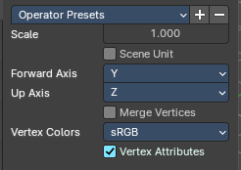
Stanford (PLY)
The Stanford Triangle Format was designed to store three-dimensional data from 3D scanners. It is a static file format for mesh data, and cannot carry animation data.

Scale
The scale factor for the imported geometry.

Scene Unit
Apply current scene units at importing the geometry.

Forward Axis
The forward axis for the imported geometry.

Up Axis
The up axis for the imported geometry.

Merge Vertices
Merges vertices by distance.

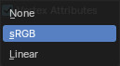
Vertex Colors
Vertex colors settings if existent.

Vertex Attributes
Import custom vertex attributes.

STL
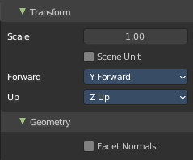
STL (Standard Triangulation/Tessellation Language ) is a standard format for many cad software. It is a format for static geometry, it cannot handle animation. The format is popular for 3d printing purposes.

Transform Panel

Scale
The import scale.

Scene Unit
Apply the scene unit at the geometry at import.

Forward
The Forward orientation at import.

Up
The Up orientation at import.

Facet Normals
Import the geometry with faceted faces.

FBX
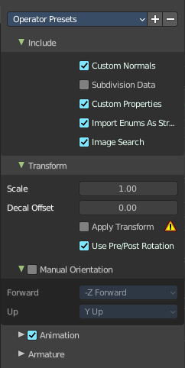
FBX is a proprietary file format from Autodesk. FBX is a general file format that is able to store and load animation.

Include Panel
What data to import.

Custom Normals
Import custom normals.

Subdivision Data
Import Subdivision.

Custom Properties
Import User properties as Custom properties

Import Enums as Strings
Store enumeration values as strings.

Image Search
Search the sub directions for associated images.

Transform Panel

Scale
Adjust the scale factor at import.

Decal Offset
Displace geometry of alpha meshes.

!Experimental! Apply Transform
Bake space transform into object data. This avoids unwanted rotations when the target space is not aligned with the Bforartists space. Warning! This feature is experimental. Use at own risk.

Use Pre/ Post Rotation
Use Pre or Post Rotation from FBX transform. This feature may not work in all cases.

Manual Orientation panel
Enables custom orientation instead of using the orientation from the fbx file.

Forward
The Forward orientation at import.

Up
The Up orientation at import.

Animation Panel

Animation Offset
Adjust an offset in frames for the imported animation.

Armature Panel

Ignore Leaf Bones
Ignore the last bone at the end of the chain.

Force Connect Children
Force connection of the children bones to their parent.

Automatic Bone Orientation
Try to align the mayor bone axis with the bone children.

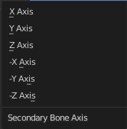
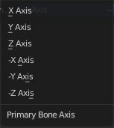
Primary and secondary Bone Axis
Manually adjust the bone orientation per axis. Note that this features are greyed out when Automatic Bone Orientation is ticked.

glTF 2.0 (glb, gltf )
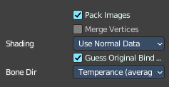
The GL Transmission Format from the Khronos Group is a file format for 3D scenes and models, and is based at the JSON standard.

Pack Images
Pack all images into the Blend file at loading the glTF file.

Merge Vertices
glTF stores every vertice of faces as an extra vertice. There is no shared vertice between two faces. Merge vertices merges the vertices of neighbor faces together.
Attiention! It currently cannot combine vertices with different normals.

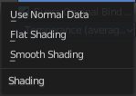
Shading
Define the shading of the imported geometry.
Use Normal Data uses the existing Normals.
Flat shading shades the whole mesh flat and faceted.
Smooth shading shades the whole mesh smooth.

Guess original bind pose
Tries to guess the original bind pose for skinned meshes. Off means the rest pose is used as the bind pose.

Bone Direction
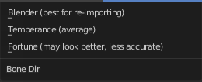
Heuristic method for placing bones.

Wavefront(OBJ) (legacy)
This is the legacy Obj importer.
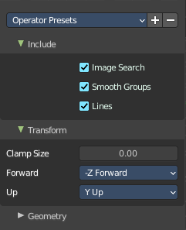
Wavefront Obj is a file format for static geometry. And while you can still create a sequence of meshes for animation with it (some software stores shape keys that way for example), you cannot store animation in the file. It is also unique since it is usually made of two files. A OBJ part that contains the mesh data. And a MTL part that contains the material including the connected textures.

Include panel

Image Search
Search sub directions for associated images.

Smooth Groups
Surround smooth groups by sharp edges.

Lines
Import Lines and Faces with 2 verts as edge.

Transform Panel

Clamp Size
Clamp bounds under this value. A value of zero disables this feature.Forward
The Forward orientation at import.

Up
The Up orientation at import.

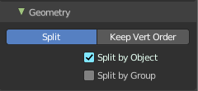
Geometry Panel

Split / Keep Vert Order
Split splits the mesh up. Keep Vertex Order imports everything as one mesh. Both methods have some further options.

Split by Object
Import loose mesh parts as single objects.

Split by Group
Import Obj Groups as meshes.

Keep Vert Order Poly Groups
Import Obj groups as vertex groups.

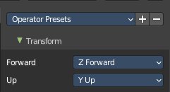
X3D Extensible 3D
Extensible 3D (X3D) is a family of co-ordinated royalty-free open standards for file formats that can store representations of interactive 3D objects and scenes.

Transform Panel
The scale factor.

Forward
The forward orientation.

Up
The up orientation.

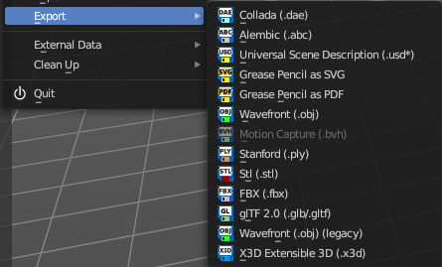
Export
Export is a sub menu with the available export formats.

Operator Presets
The operator presets exists on nearly all im- and exporters. Exceptions are for example the stl importer. They allow you to reset the importer settings to the defaults. And allow you to store your own presets. The presets are just valid for the im- or exporter with which you have saved the presets.

Operator Presets dropdown

Restore Operator Defaults
Restores the im or exporter settings to their default values

List of available presets
The list of available presets. The string *Missing Paths* indicates that no custom preset exists yet.

Add Operator Preset
Adds a new operator preset. A popup dialog will appear where you can give the new preset a name.

Remove Operator Preset
Removes the active preset. Note that you cannot display the current active preset. So choose it from the list, and then click at the remove operator.

Collada
Exports a file in collada file format. Collada is a general file format that is able to store and load animation.

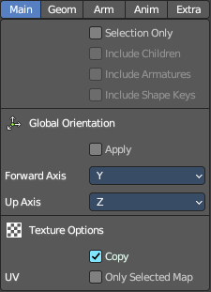
The Collada exporter is divided into several sub tabs since it would be too much to display all settings at once.

Main

Selection Only
Only export selected elements, not the whole scene.

Include Children
Export all children of selected objects, even if not selected.

Include Armatures
Export related armatures, even if not selected.

Include Shape Keys
Export all shape keys from Mesh Objects.

Global Orientation

Apply
Rotate all root objects to match the global orientation. With this option off the global settings are used by a collada object basis.

Forward Axis
The forward axis orientation.

Up Axis
The up axis orientation.

Texture Options

Copy
Copy the textures to the same folder where the .dae file is exported.

UV

Only Selected Map
Export only the selected UV map.

Geom
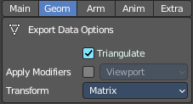
The geometry export section.

Export Data Options

Triangulate
Triangulates the mesh at export.

Apply Modifiers
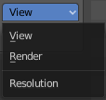
Applies the modifiers for export. The resolution can be adjusted in the drop down box behind the Apply Modifiers checkbox. You can choose between View and Render.

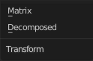
Transform
The transform type. Either transform the whole matrix. Or decomposed into the single components.

Arm
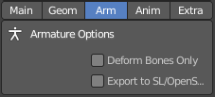
The armature export section.

Armature Options

Deform Bones only
Only export deforming bones with armatures.

Export to SL/OpenSim
Compatibility mode for SL, OpenSim and other compatible online worlds.

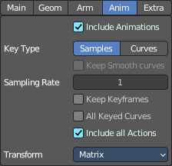
Anim
The Animation export section.

Include Animations
Export Animation if available.

Key Type

Samples/Curves
Export sample keys or curves keys.

Keep Smooth Curve
Just available with TransRotLoc transformation type. Export also the curve handles if available.

Sampling Rate
The distance between two key frames.

Keep Key frames
Use existing key frames. as sample points.

All Keyed Curves
Export also curves that has just one key or are completely flat.

Include all Actions
Export also unassigned actions.

Transform Type
The transform type for translation, scale and rotation. Matrix or TransRotLoc.

Extra
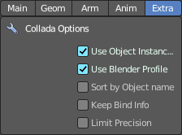
Some extra export settings.

Collada Options

Use Object Instances
Instantiate multiple objects from same data.

Use Blender Profile
Export Blender specific settings for shader, bones, materials, etc.

Sort by Object Name
Sort exported data by name.

Keep Bind Info
Store Bind Pose Information in custom bone properties for later use during Collada export.

Limit Precision
Reduce the precision of the exported data to 6 digits.

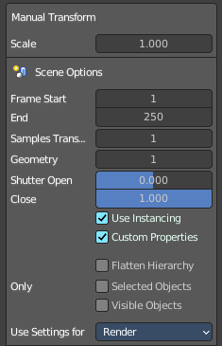
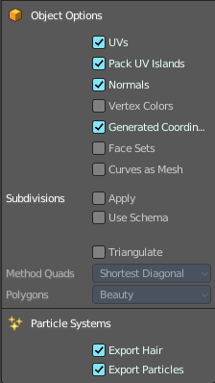
Alembic
The alembic file format is for static geometry. It does not support armatures, hair or particles. However, there are some options to export at least some data of it.
The alembic export options are divided into four sections.

Manual Transform

Scale
The export scale factor.

Scene Options

Frame Start
The start frame of the export.

End
The end frame of the export.

Samples Transform
Number of times per frame at which animated transformations are sampled.

Geometry Samples
Number of times per frame at which geometry transformations are sampled.

Shutter Open
The start frame to sample transform and geometry samples. Valid range is -1 to 1. -1 indicates the previous frame, 0 indicates the current frame, and 1 indicates the next frame.

Shutter Closed
The end frame to sample transform and geometry samples. Valid range is -1 to 1. -1 indicates the previous frame, 0 indicates the current frame, and 1 indicates the next frame.

Use Instancing
Export data duplicated objects as alembic instances.

Custom Properties
Export custom properties to Alembic . userProperties

Flatten Hierarchy
Remove parent / children relationship.

Only

Selected Objects
Export selected objects only.

Visible Objects
Export visible objects only.

Object Options

UV's
Export UV's. Note that Alembic just supports a single UV map.

Pack UV Islands
Export UV's with packed islands.

Normals
Export Normals.

Vertex Colors
Export Vertex Colors.

Generate Coordinates
Export undeformed mesh vertex coordinates.

Face Sets
Export per Face shading group assignments.

Curves as Mesh
Export Curves and Nurbs surfaces as meshes.

Subdivisions

Apply
Export subdivision surfaces as meshes. Means apply subdivision modifier before export.

Use Schema
Export meshes using Alembic's subdivision schema.

Triangulate
Triangulate meshes before export.

Quad Method
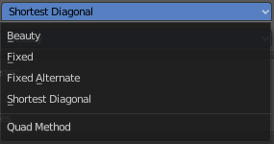
The quad method that gets used to triangulate the meshes. You need to activate Triangulate.

Polygon Method
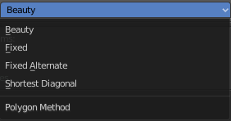
The polygon method that gets used to triangulate the meshes. You need to activate Triangulate.

Particle Systems
Alembic does not support hair or particles. However, here you can find some options to export at least some data of it.

Export Hair
Export hair particle systems as animated curves.

Export Particles
Export non-hair particles.

Universal Scene Description ( USD )
USD is a system for authoring, composing and reading hierarchically organized scene description. It is developed by Pixar.

Export settings

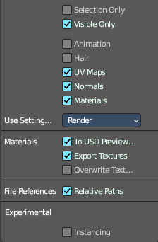
Selection Only
Export just the selected object(s), and not the whole scene.

Visible Only
Export visible geometry only.

Animation
Export animation.

Hair
Export hair.

UV Maps
Export UV Maps.

Normals
Export Normals.

Materials
Export Materials.

Use Settings for
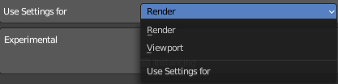
Use the render settings or the viewport settings for the export.

Materials

To USD Preview Surface
Generate a USD preview shader.

Export Textures
Export referenced textures to a "textures" directory.

Overwrite Textures
Overwrite existing textures.

File References

Relative Texture Paths
Make the texture paths relative to the usd file.

Experimental

Instancing
Istanced objects are exported as references in USD. Else they are exported as real objects.

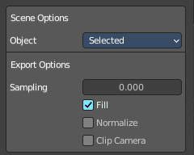
Grease Pencil as SVG
Exports the grease pencil object as a svg file.

Scene Options

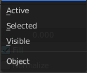
Object
What kind of objects to export from the scene.

Export Options

Sampling
Precision of Stroke sampling. Low values gives high precision. Zero disables the feature.

Fill
Export strokes with fill enabled.

Normalize
Export strokes with constant thickness.

Clip Camera
Clip drawings to camera size when exporting.

Grease Pencil as PDF
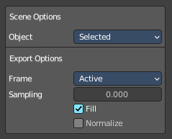
Exports the grease pencil object as a pdf file.

Scene Options

Object
What kind of objects to export from the scene.

Export Options

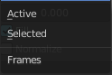
Frame
Which frames to include in the export. The active frame or the selected frames. The active frame must not be the selected frames since you can select more than one.

Sampling
Precision of Stroke sampling. Low values gives high precision. Zero disables the feature.

Fill
Export strokes with fill enabled.

Normalize
Export strokes with constant thickness.

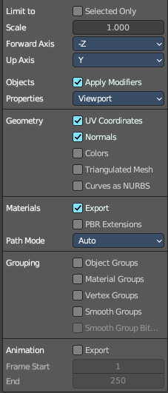
Wavefront(OBJ)
Wavefront Obj is a file format for static geometry. And while you can still create a sequence of meshes for animation with it (some software stores shape keys that way for example), you cannot store animation in the file. It is also unique since it is usually made of two files. A OBJ part that contains the mesh data. And a MTL part that contains the material including the connected textures.

Limit to

Selected Only
Just export the selected geometry.

Scale
The export scale factor.

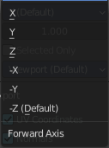
Forward Axis
Which axis points foward.

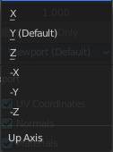
Up Axis
Which axis points upwards.

Object

Apply Modifiers
Apply modifiers before exporting the geometry.

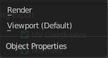
Properties
Where to grab the object properties from. They can differ between viewport settings and render settings.

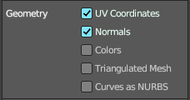
Geometry
What kind of data to export. The labels should be self explaining.
Note that the OBJ file format cannot carry the Blender material settings. The Obj file format uses a primitive Phong shader.

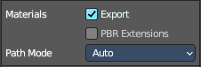
Materials

Export
Export MTL Library. You need a Principled Node with a texture node connected.

PBR Extensions
Export MTL Library using PBR extensions. Roughness, Metallic, Sheen, Clearcoat, Anisotropic and Transmission.

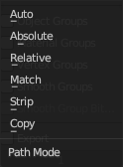
Path Mode
The method to use reference paths.

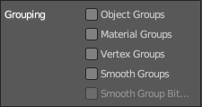
Grouping export
What kind of relationship data to export. The labels should be self explaining.
Note that the OBJ file format cannot carry the Blender material settings. The Obj file format uses a primitive Phong shader.

Animation

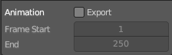
Export Animation
Export the animation. Note that Obj is no file format that can store animations. What gets exported is a sequence of single meshes.

Frame Start / End
The frame start and frame end of the animation.

Motion Capture BVH
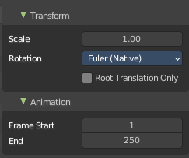
The Biovision Hierarchy (BVH) character animation file format is a file format to carry motion capture data.
To export BVH you need to have an armature with animation selected.

Transform Panel

Scale
The scale factor for the export.

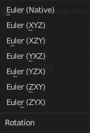
Rotation
The rotation order that is defined in the BVH file.

Root Translation Only
Only write out translation values for the root bone.

Animation Panel

Start Frame
The start frame of the animation.

End Frame
The end frame of the animation.

Stanford (PLY)
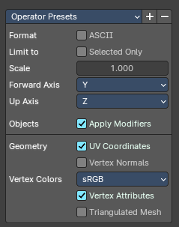
The Stanford Triangle Format was designed to store three-dimensional data from 3D scanners. It is a static file format for mesh data, and cannot carry animation data.

Format

Ascii
Ascii format when ticked, else binary format.

Limit to

Selected only
Limit the export to the selected geometry only. Else it exports the whole scene.

Scale
The scale factor for the export.

Forward Axis
The forward orientation of the geometry.

Up Axis
The up orientation of the geometry.

Objects

Apply Modifiers
Apply all modifiers before export.

Geometry

UV Coordinates
Export UV Coordinates

Vertex Normals
Export Normals.

UV's
Export UV's.

Vertex Colors
Vertex Color settings if available.

Vertex Attributes
Export vertex attributes.

Triangulated Mesh
Export the geometry triangulated.

STL
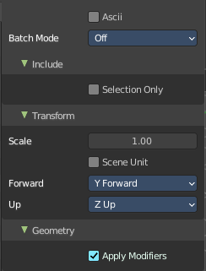
STL (Standard Triangulation/Tessellation Language ) is a standard format for many cad software. It is a format for static geometry, it cannot handle animation. The format is popular for 3d printing purposes.

ASCII
You can either export the file as binary format or as ASCII format.

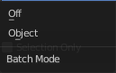
Batch Mode
Export all geometry to one file or create a file for every object.

Include Panel

Selected Only
Export only the selected object(s).

Transform Panel

Scale
The import scale.

Scene Unit
Apply the scene unit at the geometry at export.

Forward
The Forward orientation at export.

Up
The Up orientation at export.

Geometry panel

Apply Modifiers
Apply all modifiers before export.

FBX
FBX is a proprietary file format from Autodesk. FBX is a general file format that is able to store and load animation.
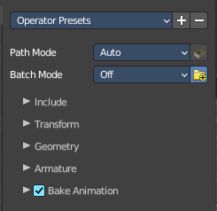
The FBX exporter is divided into several panels since it would be too much to display all settings at once.

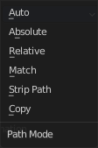
Path Mode
Method used to reference paths.

Embed Textures
Embed textures in the FBX Binary. Just with method Copy!

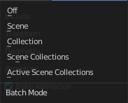
Batch Mode
Gives the opportunity to batch export independent parts. Like one file for each scene. Or one file for each collection.

Batch Own Dir
Setup the export directory for batch export.

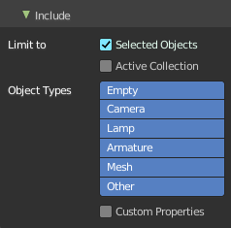
Include Panel

Limit to

Selected Objects
Export just selected objects.

Active Collection
Export just the active collection.

Object Types
What object types in the scene to export. Holding shift key adds to the current selection.

Custom Properties
Export custom properties if available.

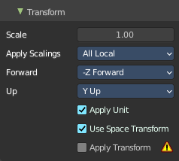
Transform Panel

Scale
The scale factor for export.

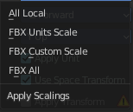
Apply Scaling
How to apply custom and unit scaling in the generated FBX file.

Forward
The forward orientation.

Up
The up orientation.

Apply Unit
Take the current Blender Units into account.

Use Space Transform
Apply global space transforms to the object rotations.

!Experimental! Apply Transform
Bake space transform into object data.

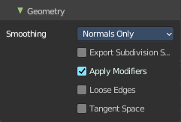
Geometry Panel

Smoothing
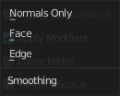
Define what smoothing information gets exported.

Export Subdivision Surface
Export the last catmull rom subdivision modifier as FBX subdivision. This does not apply the modifier, even if apply modifiers is enabled.

Apply Modifiers
Apply existing modifiers before exporting.

Loose Edges
Export loose edges. Loose edges are polygons with just two vertices.

Tangent Space
Add binormal and tangent vectors together with the tangent space information. This feature just works with tris or quads.

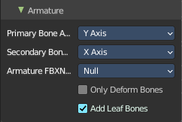
Armatures
.

Primary Bone Axis
The primary bone axis orientation.

Secondary Bone Axis
The secondary bone axis orientation.

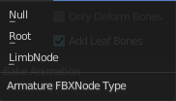
Armature FBX Node Type
FBX type of node used to represent a Blender Bone.

Only Deform Bones
Only export deforming bones, and none deforming ones when they have children.

Add Leaf Bones
Add a final bone at the end of every bone chain.

Bake Animation
Export baked keyframe animation.

Key all Bones
Force export at least one key of animation for all bones.

NLA Strips
Export each non muted NLA strip.

All Actions
Export each action as a separated FBX anim stack.

Force Start/ End Keying
Always add a key frame at start and end of actions for animation channels.

Sampling Rate
How often to evaluate animated values, in frames.

Simplify
Simplify the animation. 0.0 to disable. 1.0 does not simplify at all. Higher values simplifies the animation then.

glTF 2.0 (glb, gltf )
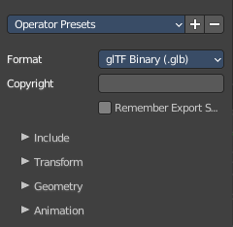
The GL Transmission Format from the Khronos Group is a file format for 3D scenes and models, and is based at the JSON standard.

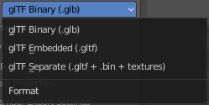

Format
Choose between three export formats. Binary, Embedded and Separate.

Copyright
Enter a custom copyright string.

Remember Export Settings
Store glTF settings in the blender project. You need to save the project then.

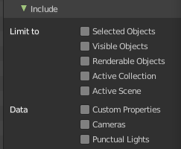
Include panel

Limit to
Limit the export to the chosen selection.

Selected Objects
Export just selected objects.

Visible Objects
Export just visible objects.

Renderable Objects
Export just renderable objects.

Active Collection
Export just selected objects from the active collection.

Active Scene
Export everything in the active scene

Data

Custom Properties
Include custom properties in the export.

Cameras
Include cameras in the export.

Punctual Lights
Include punctual lights in the export.

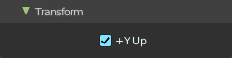
Transform Panel

Y Up
Export all objects with the Y up orientation.

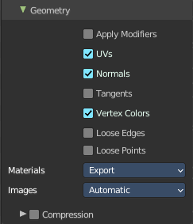
Geometry Panel

Apply Modifiers
Apply all modifiers before export.

UV's
Export UV's

Normals
Export Normals.

Tangents
Export Tangents.

Vertex Colors
Export Vertex Colors.

Loose Edges
Export loose edges.

Loose Points
Export loose points.

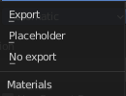
Materials
How to deal with materials at export. Export them, export with placeholders, or don't export.

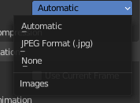
Images
How to deal with images at export.

Automatic
exports PNG images as Png Images, and Jpg Images as Jpg images.

Jpeg Format (jpg)
Exports all images as jpg.

None
Exports no images.

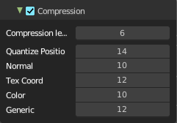
Compression sub subpanel
Compress the mesh data using the Draco algorithm.
The settings should be self explaining.

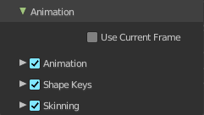
Animation

Use Current Frame
Export the scene in current animation frame.

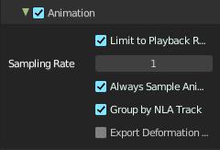
Animation sub subpanel
Export active actions and NLA tracks.

Limit to Playback Range
Clips animations to selected playback range.

Sampling Rate
How often to evaluate animated values in frames

Always Sample Animations
Apply sampling to all animations.

Group by NLA Tracks
Group actions with the same name into their own NLA tracks.

Export Deformation Bones only
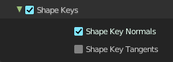
Export Deformation Bones only.

Shape Keys sub subpanel
Export Shape Keys. Also called Morph Targets.

Shape Key Normals
Export vertex Normals. with shape keys.

Shape Key Tangents
Export vertex tangents with shape keys.

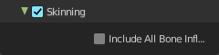
Skinning
Export Skinning data.

Include all Bone Influences
Allow vertex influences greater 4.

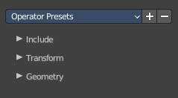
X3D Extensible 3D
Extensible 3D (X3D) is a family of co-ordinated royalty-free open standards for file formats that can store representations of interactive 3D objects and scenes.

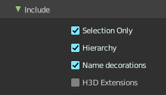
Include Panel

Selection Only
Export just selected objects.

Hierarchy
Export Parent Child relationship.

Name Decorations
Add Name Prefixes to indicate their tpye.

H3D Extensions
Export shaders for H3D.

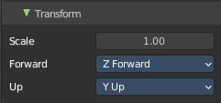
Transform Panel

Scale
The scale factor.

Forward
The forward orientation.

Up
The up orientation.

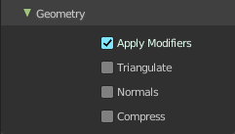
Geometry Panel

Apply Modifiers
Apply modifiers before export.

Triangulate
Triangulate the geometry before export.

Normals
Export Normals.

Compress
Compress the exported file.

External Data
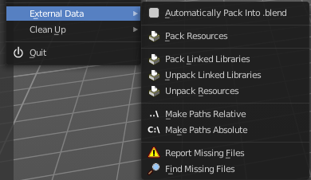
A Blend file may work with external data. Textures for example. Or text files. Or other Blend files, used as libraries.
In this menu you can adjust some settings for external data.
External data like textures or text files can also be packed directly into the blend file. This has some advantages, like that now all data is in one file. But also some drawbacks. Texture editing is for example not longer possible. You would have to export the texture first to be able to save the modifications.
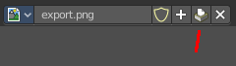
Packed data displays a packed icon in the drop down box. This example is from the header of the UV editor. But you can see this icon also in the material editor at the texture node then.
Library Blend files cannot be packed. Use append instead of link to have the data of another blend file in the blend file.

Automatically Pack into .blend
Automatically pack all files into the blend file. Don't forget to save the blend file. Note that this greys out the two menu items Pack all into Blend and Unpack packed Files.

Pack Resources
Packs all external data into the blend file. Note that the paths must fit, and the external data must be available. A common pitfall here is that the textures uses absolute paths, and are moved to another location meanwhile. See Make all Paths Relative or Find missing Files. Or that you have a not longer existing file linked that shouldn't be in the blend file at all. See Outliner, Orphan Data.

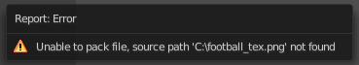
You will get a warning when something is missing.

Pack linked libraries
Pack all linked library files into the current .blend file

Unpack linked libraries
Unpack all linked library files from the current .blend file to their original locations.

Unpack Resources
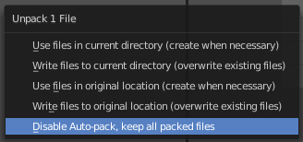
Unpack packed files exports all packed data. You will get an options menu choose between several different unpack methods.

Use Files in current Directory (create when necessary)
Extracts all files to the current directory of the blend file. If the files in the current directory exists, reuse it. Else extract the ones from the blend file.
NOTE! The title is misleading, it does NOT write the files to the current directory. But into a sub folder, textures for example, in the current directory. Which gets created if necessary. And this option is not to change.

Write files to current directory (overwrite existing files)
Extracts all files to the current directory of the blend file, and writes it to the current directory. Existing content will be overwritten.
NOTE! The title is misleading, it does NOT write the files to the current directory. But into a sub folder, textures for example, in the current directory. Which gets created if necessary. And this option is not to change.

Use files in original location (create when necessary)
Extracts all files into their original directories where they were before packing them into the blend file. If the files in the original directory exists, reuse it. Else extract the ones from the blend file. This feature uses absolute paths.

Write files to original location(overwrite existing files)
Extracts all files into their original directories where they were before packing them into the blend file. If the files in the original directory exists, reuse it. Else extract the ones from the blend file. This feature uses absolute paths.

Make Paths Relative
The path will be shortened to just the file name. For example, C:\myfolder\mysubfolder\mytexture.jpg turns into texture.jpg . Relative paths allows you to move the whole project folder to another location. The file paths will still be valid.

Make Paths Absolute
Makes all paths absolute. For example, texture.jpg turns into C:\myfolder\mysubfolder\mytexture.jpg. Absolute paths requires the full valid path for all files.

Report Missing Files
Scans through the blend file and tries to find missing files. You will get a warning when a missing file is found.

Find Missing Files
Browse for the new location of moved files.

Clean Up
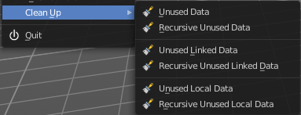
Here you can remove unused data. It removes all data from the scene that is not longer in use and has no fake user assigned to keep it in the scene.

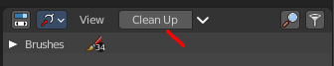
It is similar functionality to the Clean Up feature in the outliner. But more granular. Unused Data does the same than the purge button in the outliner.

Unused Data
Removes unused data blocks.

Recursive Unused Data
Recursively removes unused data blocks. Means the child objects gets removed too.

Unused Linked Data
Removes unused data that is linked to this file.

Recursive Unused Linked Data
Recursively removes unused data that is linked to this file. Means the child objects gets removed too.

Unused Local Data
Removes unused local data.

Recursive Unused Local Data
Recursively removes unused local data. Means the child objects gets removed too.

Quit
Quit Bforartists.

